Stand up and fight
Student: ………………………..…………..…..…..…………… Class: …..…….....………. Due date: …..…….…………………...
By the eleventh century, a new type of soldier was having a big influence on the outcome of a battle.
1. Compare SOURCES 1 and 2.
 | SOURCE 1 The Battle of Maldon, 991 CE: the English tried to repulse a Viking invasion. |  | SOURCE 2 The Battle of Hastings, 1066 CE: the English tried to repulse a Norman invasion.
 | 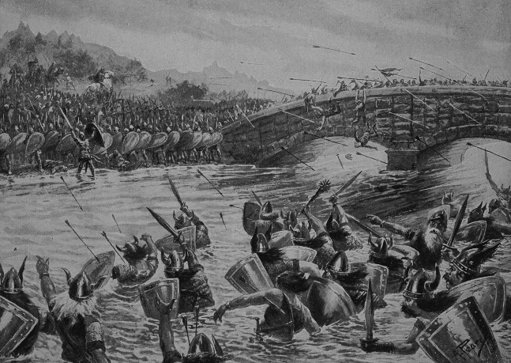  The Battle of Maldon, 991, illustration from Hutchinsons Story of the British Nation, c.1923 litho, Pearse, Alfred 19th/20th Century / Private Collection / The Stapleton Collection / Bridgeman Images |  | 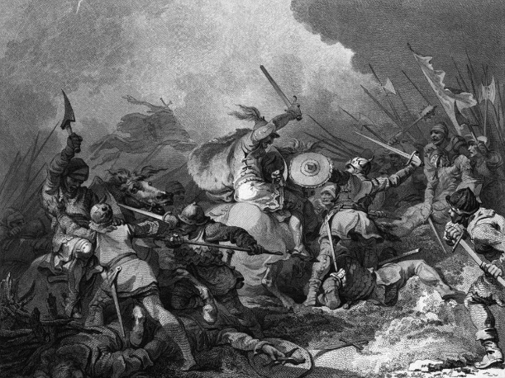

a. What new inventions assisted a soldier in manoeuvring on horseback?
i.
ii.

b. Describe two ways in which these developments would give a soldier an advantage over his enemy.
i.
ii.

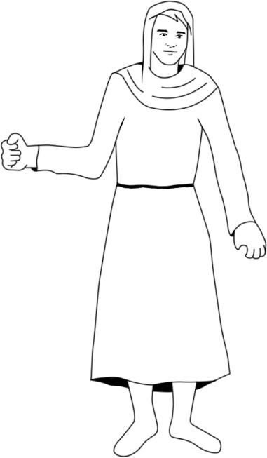
2. A knight would sometimes take his peasants into battle armed only
with what they could grab from the farm. Arm this peasant
appropriately with two items.

3. Monks could also be knights. Who and what do you think they might have
to protect? (Clue: Refer to the feudal system diagram from this topic.)

4. Look carefully at SOURCE 3, which shows the development of the knight’s armour, and then answer the questions.

SOURCE 3 The development of the knight’s armour
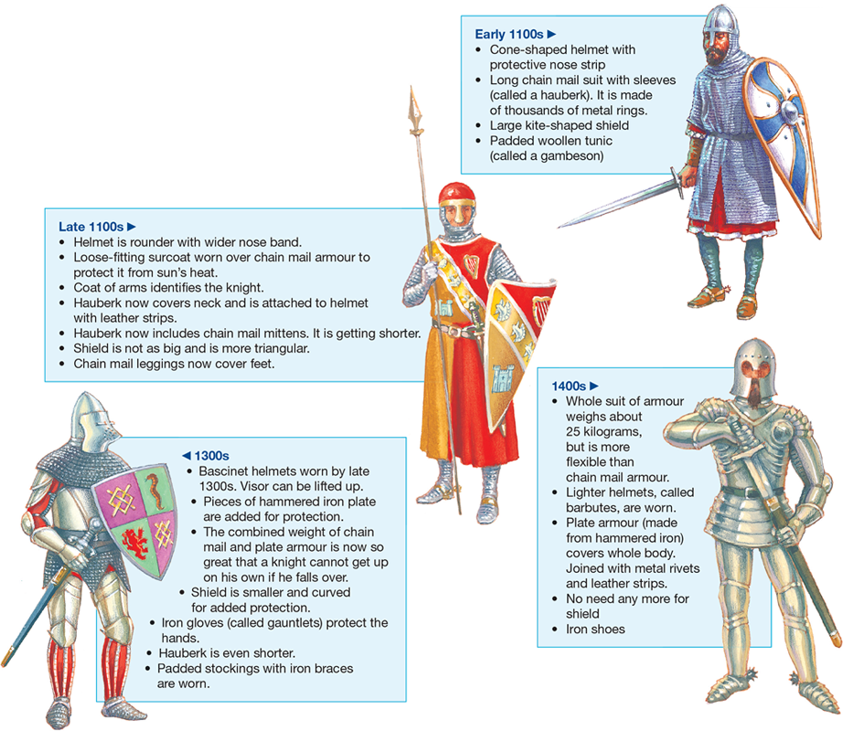

a. What would have been the most vulnerable body part for a knight in the 1100s when fighting foot soldiers? Why?

b. Why did a knight in the 1400s no longer need a shield?

5. a. Why do you think a knight would have to train?

b. Describe a well-known training event.

6. a. Although gunpowder had been invented, why didn’t medieval soldiers use guns very much before about 1500 CE?

b. What weapons were useful for long-range attacks?

c. Why was it also important for soldiers to carry pikes, swords and axes?

7. In your own words, write a short paragraph (two or three sentences) to describe a battlefield scene.

8. What new technology helped end the usefulness of knights?

9. By what century can we say that knights were history?

